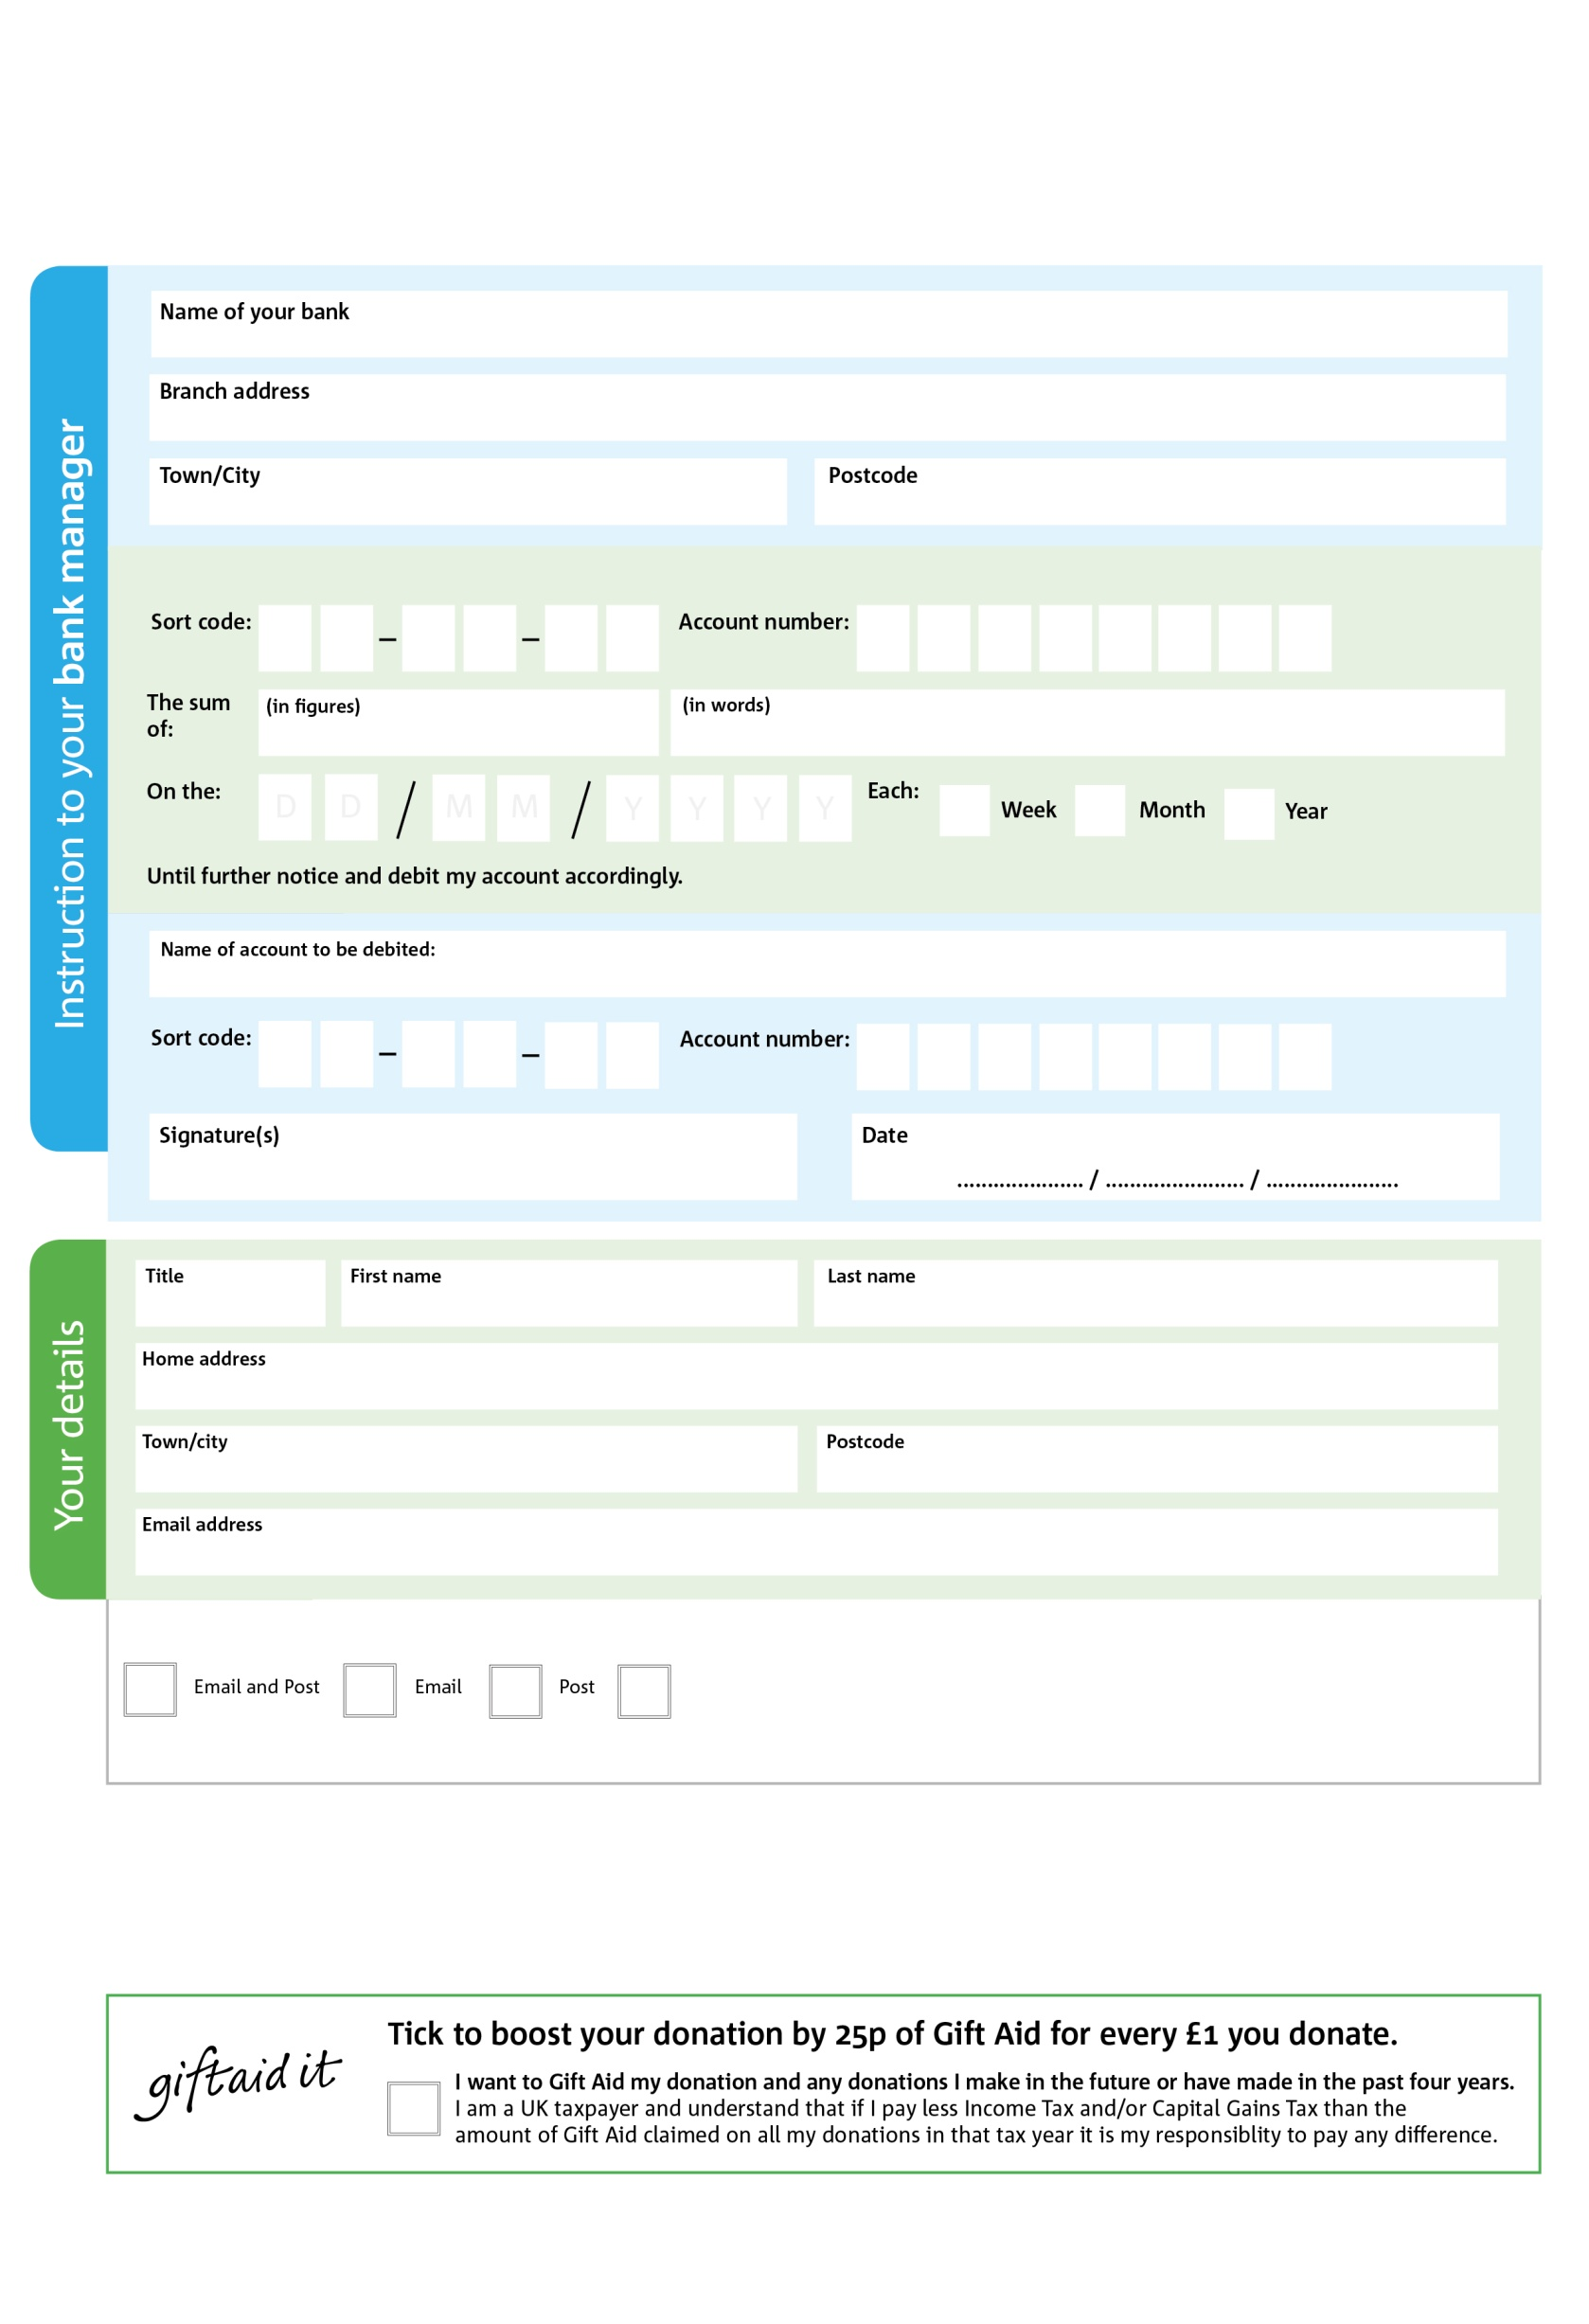

POSTAL ADDRESS: Fosse Foodbank, St Peter’s Church, Kineton C/O 60 Green Farm End, Warwick, CV35 0LD

**Please pass this form onto the foodbank, using the foodbank’s address at the bottom, who will save a copy for their records. They will then send it onto your named bank or building society.**

7X

V

7X7

V

8X

V

9X9

V

44

V

1X

V

2X

V

6X

V

9X

1X

3X

4

0

44

We would love to keep you up to date with information about Fosse Foodbank. Please tick your preference:

You can change your preferences any time by contacting us on 01926 642954 or emailing us at info@fosse.foodbank.org.uk

I do not wish to receive future communications from Fosse Foodbank

Please pay Fosse Foodbank,

**Data protection**

Fosse Foodbank is committed to protecting your privacy and will process your personal data in accordance with current Data Protection Leglisation. Fosse Foodbank collecting information to keep in touch with you and supply you with information relating to our work. Fosse Foodbank will never sell or pass your details to anyone who isn’t directly working on our behalf. A full data privacy statement for financial donors is available from the foodbank on request.

**Standing Order Mandate**

**Fosse.foodbank.org.uk**

Reg. Charity No: 1173954 | Reg. in England & Wales

You can change your preferences any time by contacting us on XXXXXXXXXXX or emailing us at XXXX@XXXXXXXXXX.foodbank.org.uk

I do not wish to receive future communications from XXXXXX Foodbank