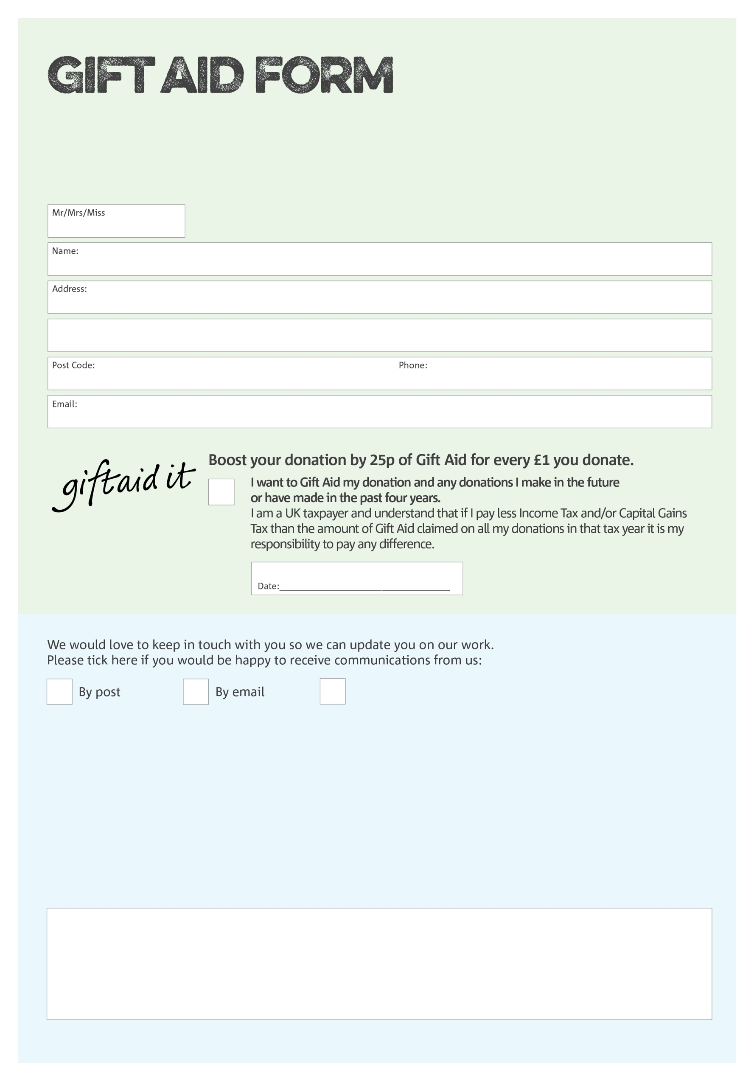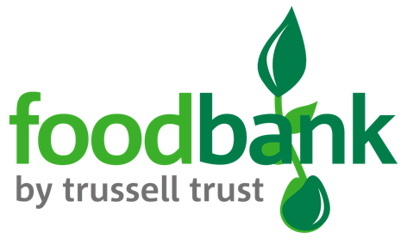

By filling in this form Fosse Foodbank will receive an extra 25p for every £1 you give at no extra cost to you. Thank you!

**Data protection**

*'Fosse Foodbank is committed to protecting your privacy and will process your personal data in accordance with current Data Protection legislation. Fosse Foodbank collects information to keep in touch with you and supply you with information relating to our work. A full data privacy statement for financial donors is available from the foodbank on request.’*

You can change your preferences any time by contacting us on 07964412010 or emailing us at

info@fosse.foodbank.org.uk

I do not wish to receive future communications from Fosse Foodbank

We would love to know why you have chosen to donate to Fosse Foodbank. If you would like to share your motivation let us know below:

Charity Number 1173954. Registered in England and Wales